

**Senior Design Project**

**The Design of Assistive Device For The Visually Impaired**

ENGE476 Senior Design Project I

Department of Engineering and Aviation Sciences

University of Maryland, Eastern Shore

Esther Olofinlua

Ruth Crippen

Chibunkem Asuzu

Project Advisor, Dr. Lei Zhang

Submitted

Wed. Nov. 7, 2018

Special notice for formatting:

1. Don’t add any blank rows. Use spacing or page breaks.
2. Every figure or picture inserted in the text, must be accompanied with the caption and detailed description.
3. Keep the formatting consistent (learn and apply the MS ‘Styles’ in formatting).
4. The final report didn’t meet the basic formatting requirements won’t be accepted.
5. **List of Contents**

**Special notice for formatting: 2**

**1.** **Don’t add any blank rows. Use spacing or page breaks. 2**

**2.** **Every figure or picture inserted in the text, must be accompanied with the caption and detailed description. 2**

**3.** **Keep the formatting consistent (learn and apply the MS ‘Styles’ in formatting). 2**

**4.** **The final report didn’t meet the basic formatting requirements won’t be accepted. 2**

**Table of Contents 3**

**Abstract 2**

**1.** **Introduction 3**

**1.1** **Background/Motivation 3**

**1.2** **Objective 3**

**1.3** **Design Requirements 3**

**1.4** **Design Constraints 3**

**1.5** **Design Methods 3**

**2.** **Project Description 4**

**2.1** **System Description 4**

**2.2** **System Diagram 4**

**2.3** **System Functions 4**

**3.** **Implementation Plan 6**

**3.1** **Tasks 6**

**3.2** **Team Organization 7**

3.2.1 Responsibility of Team Member 1. 7

3.2.2 Responsibility of Team Member 2. 7

**3.3** **Timeline/Milestones/Delivery Plan 7**

**4.** **Implementation 8**

**4.1** **Implementation of Task 1. 8**

**4.2** **Implementation of Task 1. 8**

**5.** **Conclusion. 9**

**Acknowledgement 10**

**Appendix 11**

**A.** **Component Specs 11**

1. Specs of Arduino Due 11

2. Specs of Raspberry Pi 11

**B.** **Source Code. 11**

1. Source Code of Graphic User Interface 11

2. Source Code of Robotic Arm 11

**REFERENCES 12**

1. **List of Figures**
2. **List of Tables**
3. **Abstract**

By the end of the project, summarize the project into short text and put here.

1. **Introduction**

Figure 1

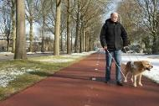

Figure 1 displays a visually impaired individual walking with his seeing-eye-dog

Visually impaired individuals have a need for an inexpensive device that can assist them with mobility and day to day tasks. While there already exist some handheld tech to that end, none of them are intuitive enough to the users, and none are revolutionary enough to be the new standard. The ADVI visually impaired assistive devices and tech will provide both convenience, cost efficiency and ease of everyday use. The overall purpose of this project is to propose a wearable device, designed for visually impaired individuals to assist them with getting around. Unlike most commercially available assistive devices, this device should alert the user of obstacles in their path.

## 

## Background/Motivation

The statutory definition of “legally blind” is that central visual acuity must be 20/200 or less in the better eye with the best possible correction or that the visual field must be 20 degrees or less.

There are no generally accepted definitions for “visually impaired,” “low vision,” or “vision loss.”

According to estimates from the World Health Organization (WHO) Prevention of Blindness and Deafness Programme:

About 285 million people are visually impaired worldwide: 39 million are blind and 246 million have low vision (severe or moderate visual impairment)

About 90 per cent of the world's visually impaired people live in developing countries

Globally, uncorrected refractive errors are the main cause of visual impairment

Cataracts are the leading cause of blindness

65 percent of visually impaired, and 82 percent of blind people are over 50 years of age, although this age group comprises only 20 percent of the world population

Top causes of visual impairment: refractive errors, cataracts and glaucoma

Top causes of blindness: cataracts, glaucoma and age-related macular degeneration

Moderate vision impairment refers to those that present visual acuity that is worse than 6/18. Severe vision impairment refers to those that present visual acuity that is worse than 6/60. Additionally, 36 million individuals in the world are blind.

Blindness refers to individuals that present visual acuity worse 3/60. As for those that are have near vision impairment, there are around 826 million individuals. Near vision, or as some refer to it as near sight, impairment refers to individuals that present near visual acuity that is worse than N6 or N8 at 40cm with existing correction.

The primary sources of vision impairment are uncorrected refractive errors and cataracts. After careful assessment and studies, it seems that about 80% of vision impairment can be avoidable. Individuals over the age of 50 years make up the majority of the visually impaired community.

Not all persons that live with visual impairment have the same lifestyles or experiences. Their experiences are a result of various factors. Among these factors are the availability of prevention and treatment interventions, access to the vision rehabilitation (including assistive products such as glasses or white canes), and whether the person experiences problems with inaccessible buildings, transport and information.

Unfortunately, the outlook on the future of visual impairment shows an estimate of the population growth and ageing increasing the risk that more people will acquire vision impairment. Our team is designing technology that will assess this growing problem.

The current methods of aid to the visually impaired comprise canes and guide dogs.

There exist other forms of had held aids using vibration and sound technology.

No other form of aid for the visually impaired people have improved their general quality of life any more than in the early recorded decades.

ADVI will aim to create a product with a system that is tailored to enrich the lives of the users greatly.

ADVI will make use of radar tech, vibration and location-awareness to alert the wearer, without the need of being hand-held. It will be a wearable that will both liberate the hands of the visually impaired subject, and communicate with him or her with the aid of vibrating components in its system.

Visually impaired individuals have a need for an inexpensive device that can assist them with mobility and day to day tasks.

Over the decades, help and support has not really improved further than a help pet such as, typically, a trained dog, or various types of canes, each with their different sets of capabilities.

In the modern world of today, while there currently exist some handheld tech to the end of facilitating visually impaired individuals’ mobility, none of the products advertised and widely in use are intuitive enough to the users. None of them are revolutionary enough in performance to be the new standard. the ADVI visually impaired assistive devices and tech we are developing will provide both convenience, cost efficiency and ease of everyday use in ways where current conventional devices are underperforming.

The goal of the ADVI we are developing through a complex algorithm and a synergetic blend of hardware, textile and software, is to provide an alternative, hands free way for the visually impaired to navigate their immediate environments perhaps more comfortably and more reliably than with a cane.

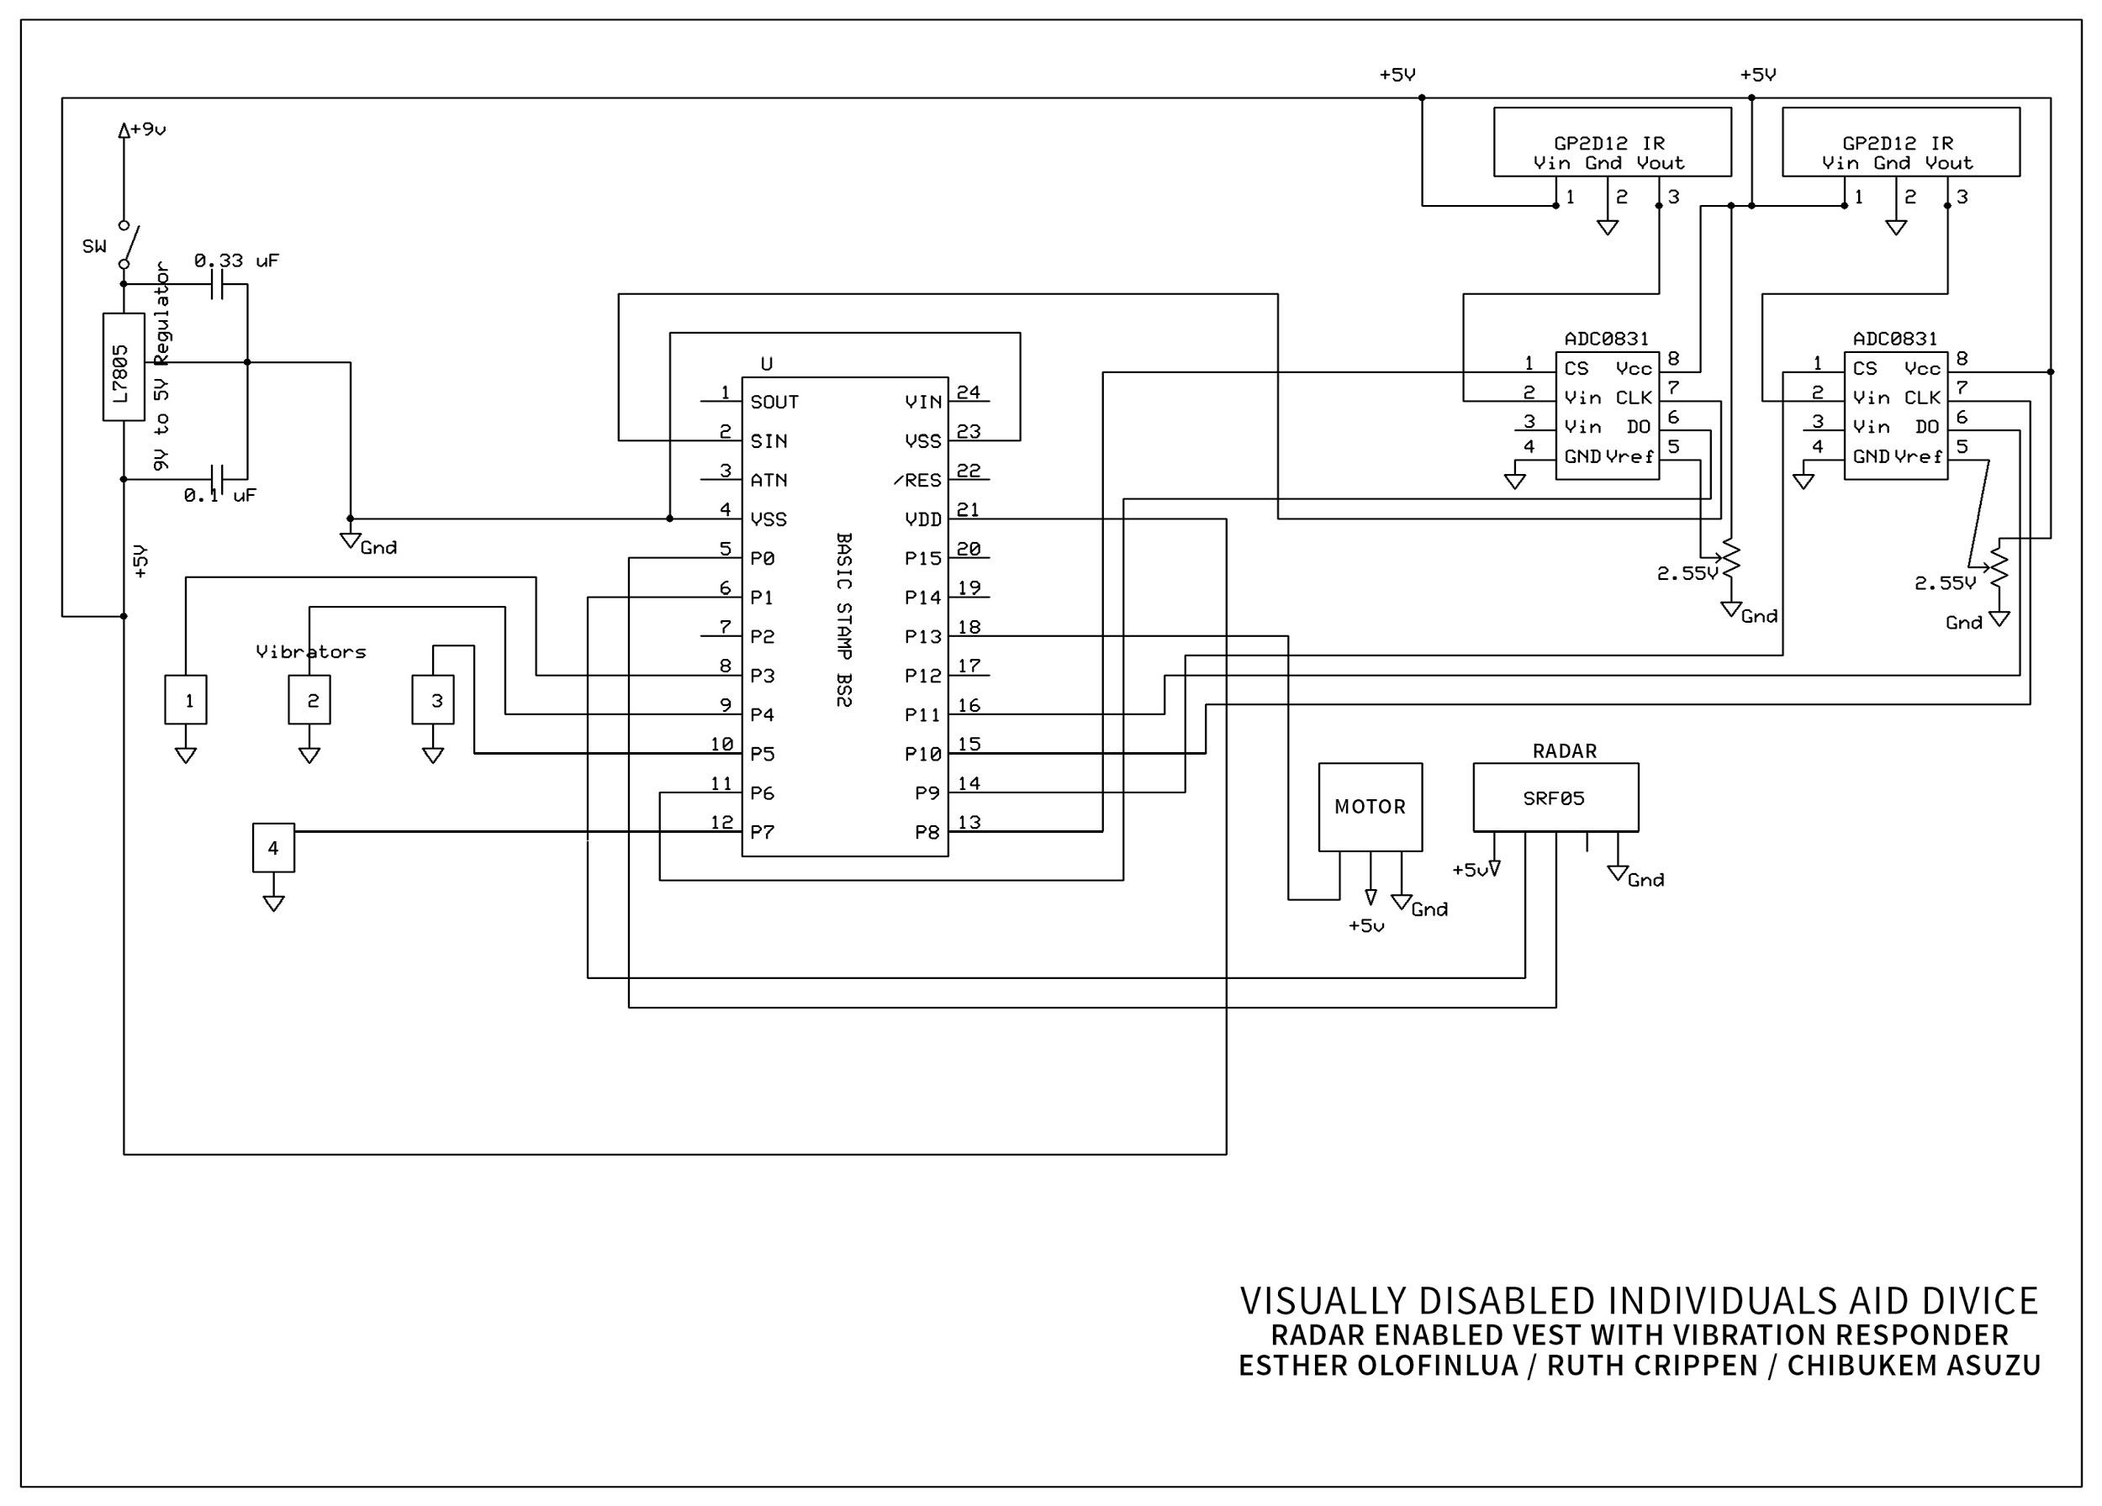

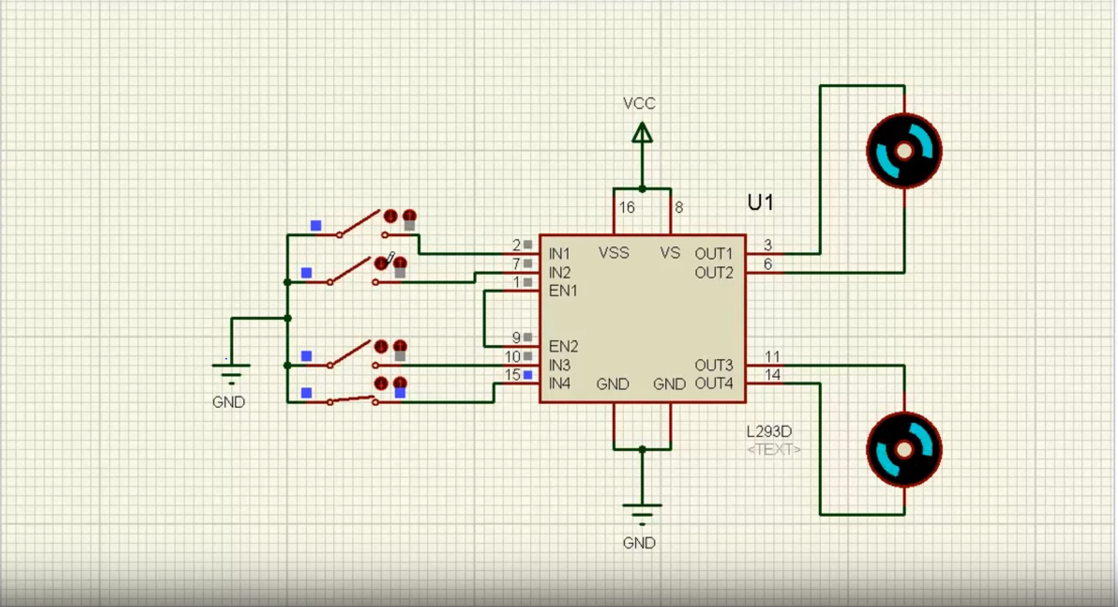

*Pictured above is a snapshot of the vibrating motor on multisims*

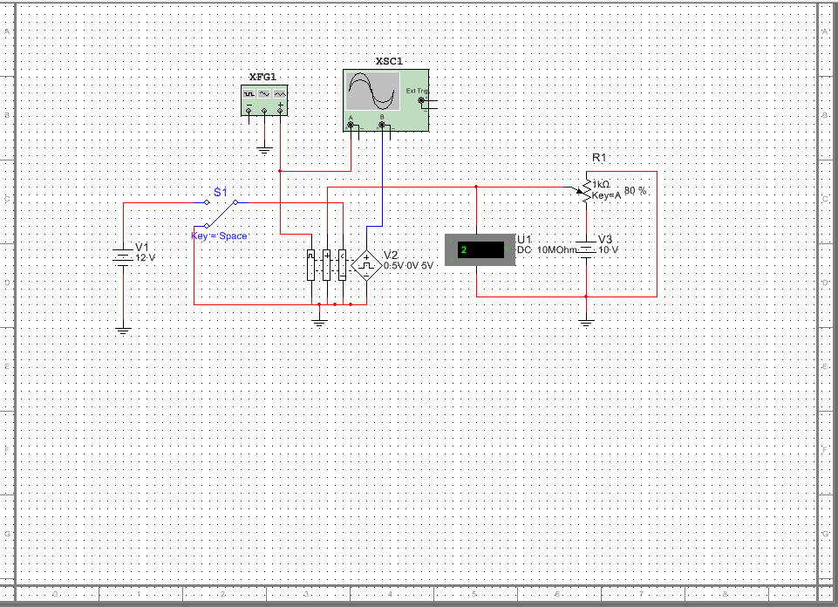

*Pictured above is a snapshot of the PWM on multisims*

## Objective

The objective is to design a hands-free wearable device. The device will be using Radar technology and an intuitive design to assist the visually impaired with easy mobility, danger avoidance, and general facilitation of day to day tasks. In the design of the device, we are considering the consumer’s perspective, such as necessity versus pleasure.

## Design Requirements

1. The device will give feedback to users of obstacles in the environment (obstacles up to 3-5 meters) through 8 vibrating motors
2. The device will include 3 vibration intensity levels (low, medium, and high)
3. The device will be adjustable with a quick 1 pull adjustable waist strip to accommodate growth and heavy clothing

## Design Constraints

* Budget
* Inoperable in certain weather conditions
* Limited Resolution (cannot detect thin wires or objects as small as a fly or as thin as a wire)
* Weight of vest depends on technology and components included in the system

## Design Methods

Figure 2



Figure 2 displays the Design Method process to undergo to complete the project

Before beginning the project a thorough investigation is required. Research and complete a series of surveys of those in the visually impaired community. The surveys allows clarification of the exact necessities of the individuals and verification that the project is viable. Present the features and the purpose of the proposed device to the individuals and document when they state their opinions based on their experiences and lifestyles. It is important to have their perspective in mind when beginning the initial design process. The next step of the investigation is finding the proper technology to fit the project requirements. The technology cannot be outdated or previously used for a similar project.

Once a substantial amount of researching and surveying is complete for the investigation stage, brainstorm ideas of what the end goal will be. To do this, sketch out how the product will look like and strategically plan the placement of the main components of the system. Then convert the sketch to a 3-Dimensional CAD model concept with SolidWorks. The purpose of this is to see the bigger picture and clearly display how the components will be placed.

After finalizing the CAD model concept, it is time for the analysis of system and the design . This includes developing algorithms for how the components connect and intersect. This step also requires for schematic diagrams of the system and circuit diagrams for the necessary components. These algorithms and schematics map out the inputs and outputs of the system and help to visualize how everything works. At this stage any trade studies of materials and components are to be finalized so that the designing can begin. Materials must also be ordered to prior to beginning the design of the device.

Once the design of the device is complete, assemble the parts as a full system. this is the prototype. the next stage is to test that all the connections operate properly. testing and refining to verify that everything works according to the requirements and then documenting the results is very important. Have various individuals tryout the wearable device to see how well it works and if the material chosen is in sync with the system.

The last stage of the process is the presentation and delivery. the information gathered and the documented results must be shared and communicated for feedback and completion of the design process. The product can then be delivered to be placed in the market.

1. **Project Description**

## System Description

## The millimeter wave sensor radar sends out electromagnetic waves into the environment to calculate the distance between obstacles and the individual. The time between the emission and the reception of the waves is then processed through the microprocessor. In this system the microprocessor is the Raspberry Pi. The vest serves as the responder. It has eight vibrating mini motor discs that are placed strategically on the vest to correspond to the direction of the obstacles. These motors are activated when the Raspberry Pi is alerted of obstacles. The mini vibrating motors vibrate accordingly, warning the user of the obstacle direction. The intensity level of the vibrations change depending on the individual’s proximity to the obstacle. as they get near the object, the vibration is stronger.

## System Diagram

Figure 3

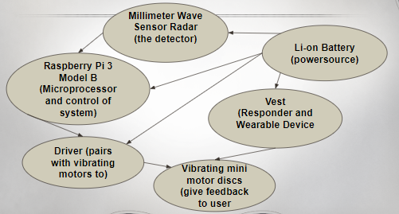

Figure 3 is a system diagram of how all the components connect and their role in the system

## System Functions

1. All of the components are located on the vest
2. The Li-on battery powers the whole system
3. The radar scans the environment through wave sensing and detects obstacles.
4. The radar then sends the information back to the system into the Raspberry Pi
5. The Raspberry Pi is the brains and control of the system
6. The Raspberry Pi takes the information from the radar and processes it
7. The Raspberry Pi then sends signals to the driver
8. the signals from the driver are multiplexed by the multiplexer
9. the multiplexer distributes the signals to the vibrating motors that correspond to the direction of the obstacle

1. **Implementation Plan**

## Tasks

* Task 1. Radar Assessment and Analyzation
  + Subtask 1.Investigate the possible Radar Technology available in the market
* create a matrix to aid in the process of the trade study
  + Subtask 2.Evaluate the outcome of the Radar matrix
* Based on the data assembled, isolate the appropriate Radar to meet the requirements of the design
  + Subtask 3.Execute a detailed analysis of the isolated Radar
* Examine datasheets and specifications closely to acquire the desired knowledge
* Task 2. Application of the Vibrating Mini Motor Discs and Drivers
  + Subtask 1.Conduct a systematic inquiry of the available vibrating disc merchandise
* Distinguish the suitable driver that pairs with the vibrating motor discs
  + Subtask 2.Develop the plan for the motors, driver and the Raspberry Pi to interface
* Create an algorithm to map out the interconnection of the components
  + Subtask 3.Design a circuit to display the flow of information to the motors
* Utilize Multisim or a similar program to simulate and display the functions of the motors with the driver and Raspberry Pi.
* Task 3. Strategic Design and Development with Raspberry Pi 3 Model B
  + Subtask 1.Assess and differentiate the preferred method for the Raspberry Pi and Radar interaction
* create an algorithm to display the functions of the components and how they interface
  + Subtask 2. write the code in Python for the Radar
* Ensure the code can be presented and tested
  + Subtask 3.Strategically estimate the optimum position of the components on the vest
* Inspect and experiment with wide range of data from various individuals as the vest test subjects
  + Subtask 4. Document trials and draw conclusions based on data gathered
* Task 4. Incorporation of the Wearable Device, Design Assembly and Verification
  + Subtask 1.Create a rough sketch of Conceptual design of the Vest
* Distinguish where components will be allocated on the vest
  + Subtask 2.Complete CAD Model of Vest Concept for a more favorable display
* Highlight established component placement
  + Subtask 3. Review and Evaluate material for optimum results as wearable device with attached componenta.
* create matrix to aid in the process of completing a material trade study for the vest
  + Subtask 4. Evaluate the outcome of the material matrix and distinguish the more favorable outcome
  + Subtask 5. Assemble all components with wearable device begin full system design verification and refinement

## Team Organization

Team member 1, 2, …. Make sure all tasks/subtasks specified in last section are clearly assigned to **a** team member (if a subtask is too much for one person, split it to more subtasks). Later he/she will be evaluated based on the evaluation and completeness of tasks he/she is responsible for.

### Responsibility of Team Member 1.

Task 1, Subtask 2.2, …

### Responsibility of Team Member 2.

…

## Timeline/Milestones/Delivery Plan

**Please prospect the timeline to deliver the results of each task/subtask.**

**Please schedule your project to no more than 22 weeks from now.**

1. **Project Timeline and Delivery Plan**

|  |  |  |  |
| --- | --- | --- | --- |
| Time | Task | Comments | Responsible Personnel |
| Week 7 | Task 1 Subtask 1& 2 | Radar Assessment and Analyzation- 3 weeks needed | Chibunkem & Esther |
| Week 10 | Task 1 Subtask 3 | Radar Assessment and Analyzation- 3 weeks needed | Chibunkem, Esther & Ruth |
| Week 11 | Task 2 Subtask 1 and 2 | Application of Vibrating Motors Discs and Driver- 2 weeks needed | Ruth |
| Week 13 | Task 2 Subtask 3 | Application of Vibrating Motors Discs and Driver- 2 weeks needed | Esther |
| Week 14 | Task 3 Subtask 1,2,3 | Strategic Design and Development with Raspberry Pi 3 Model B | Ruth & Chibunkem |
| Week 15 | Task 4 Subtask 1 & 2 | Incorporation of Wearable Device, Design Assembly and Verification | Esther |

1. **Implementation**

For each task/subtask, create a section and add tech details of how it is implemented.

## Implementation of Task 1.

## Implementation of Task 1.

Figure 4

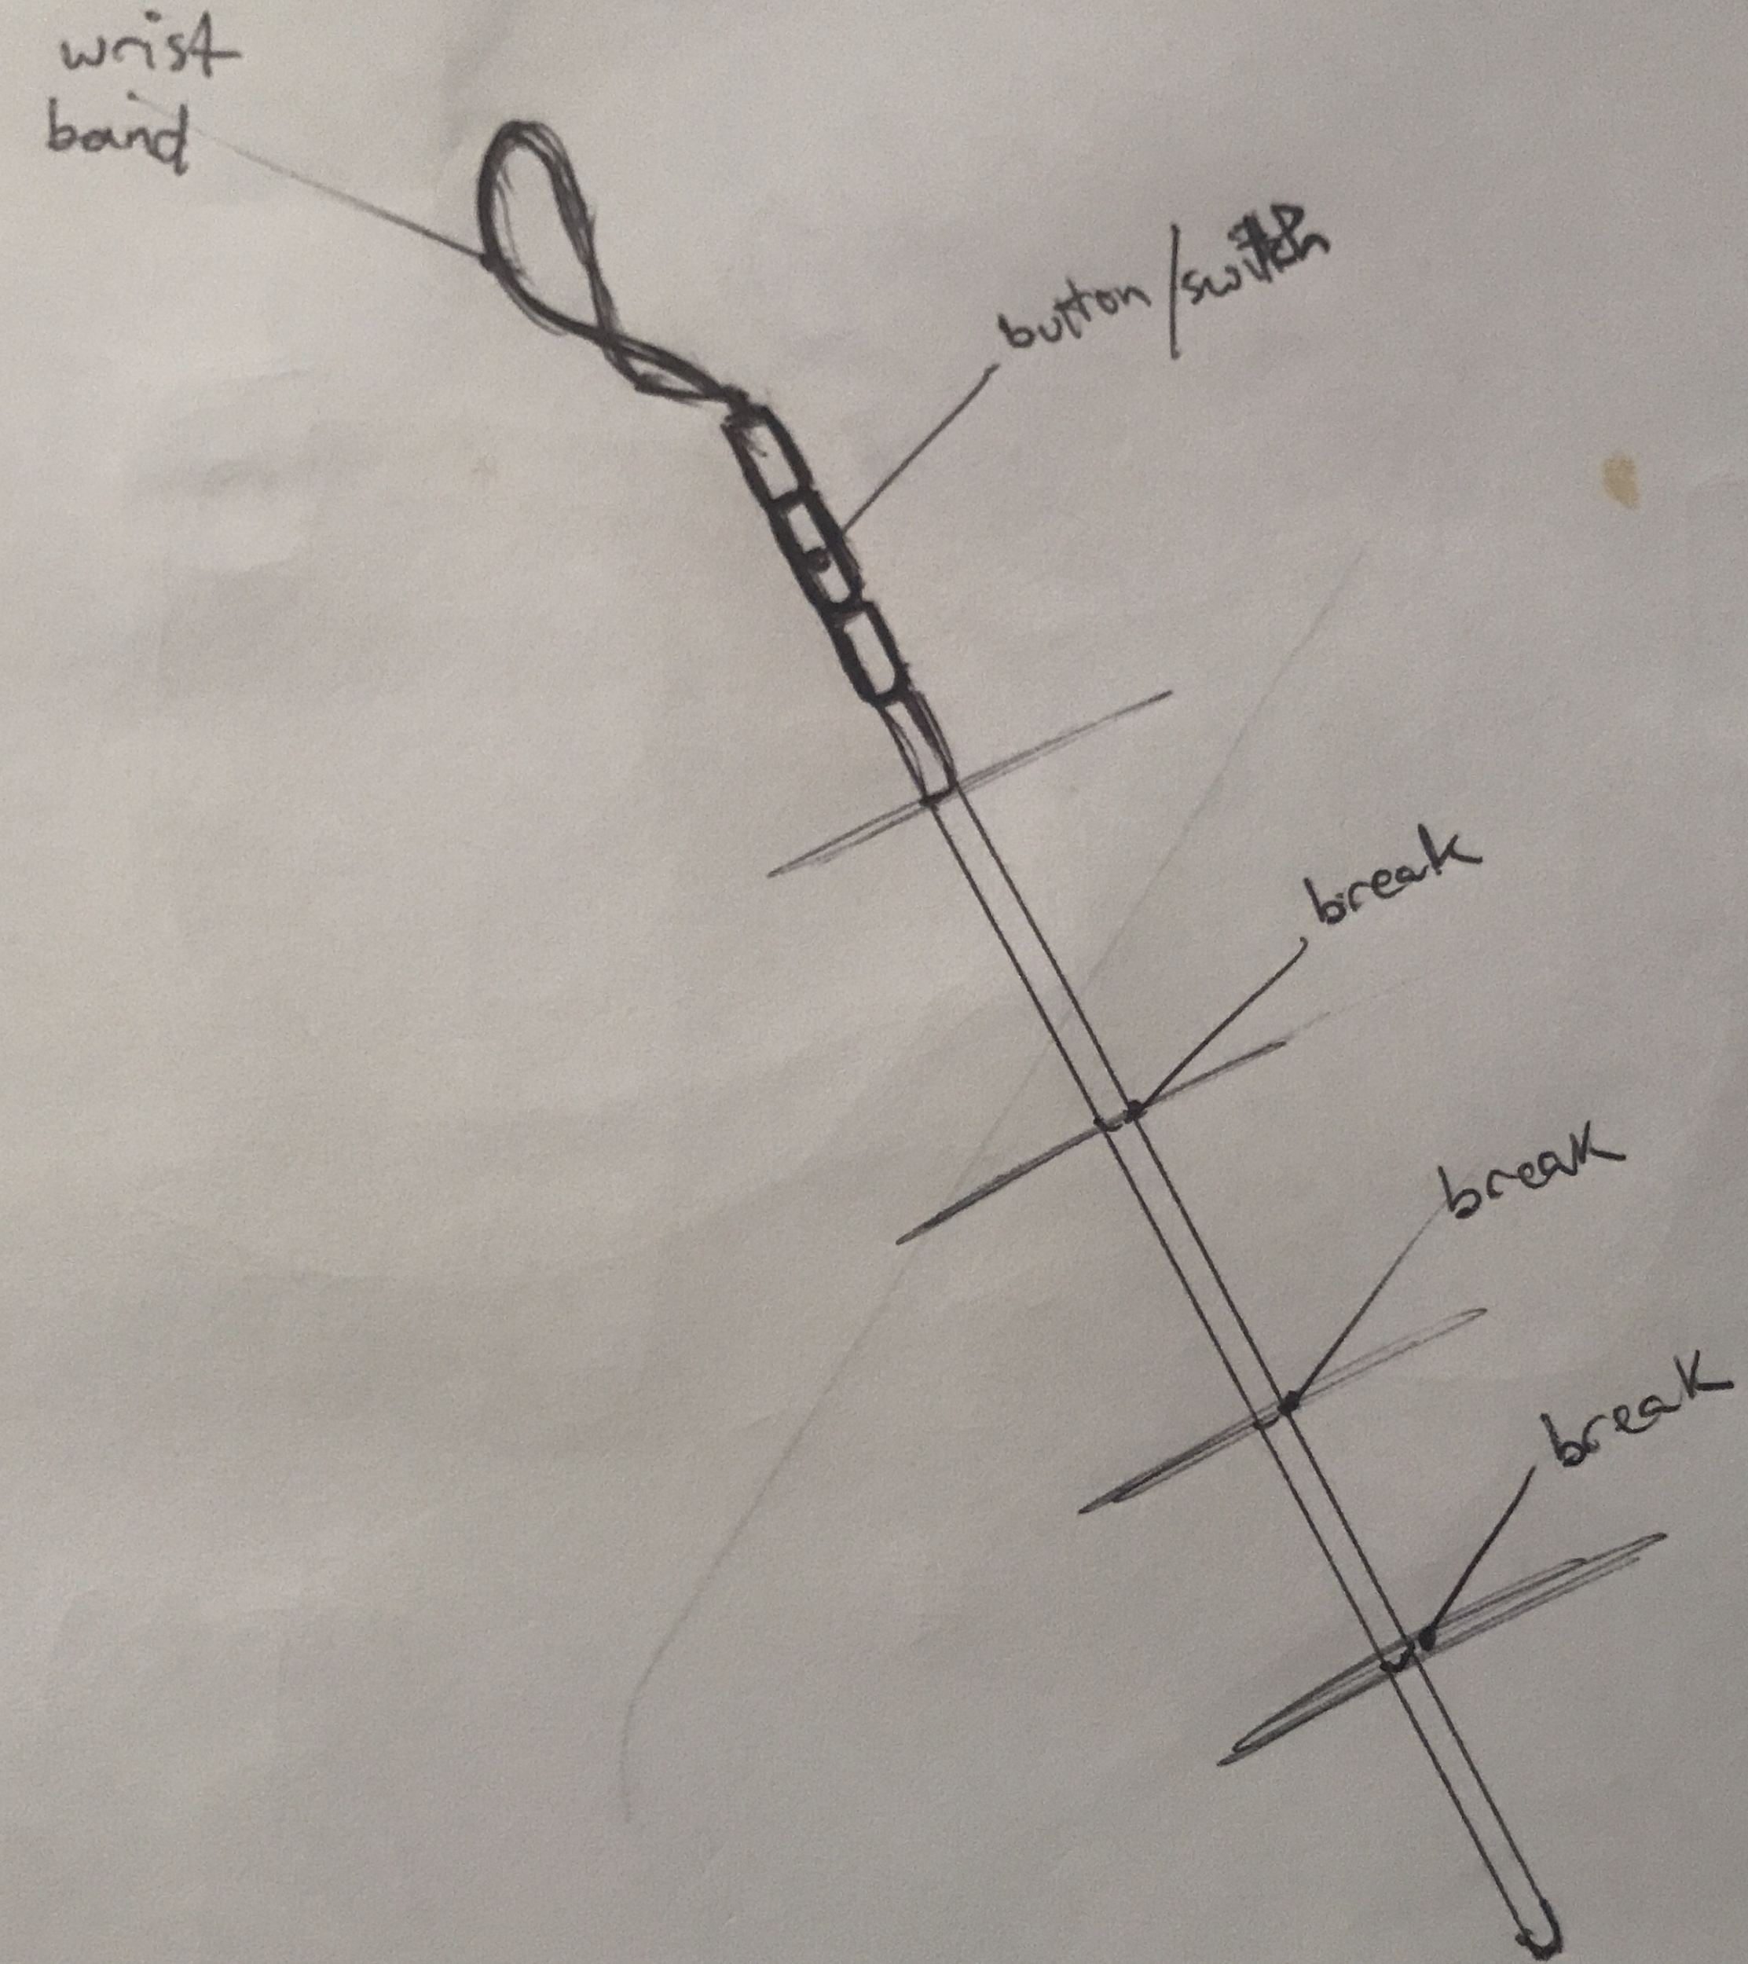

*Figure 4 displays a sketch of the initial concept of the adjustable smart cane*

Figure 5

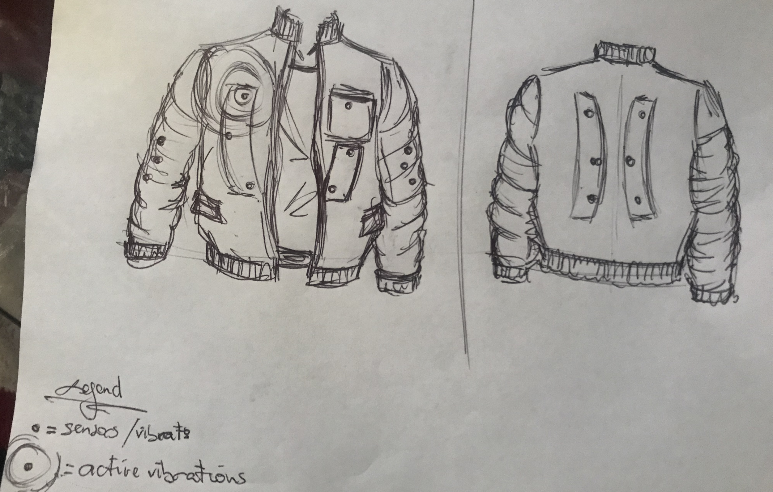

*Figure 5 displays a sketch of possible vest/jacket concept*

Figure 6

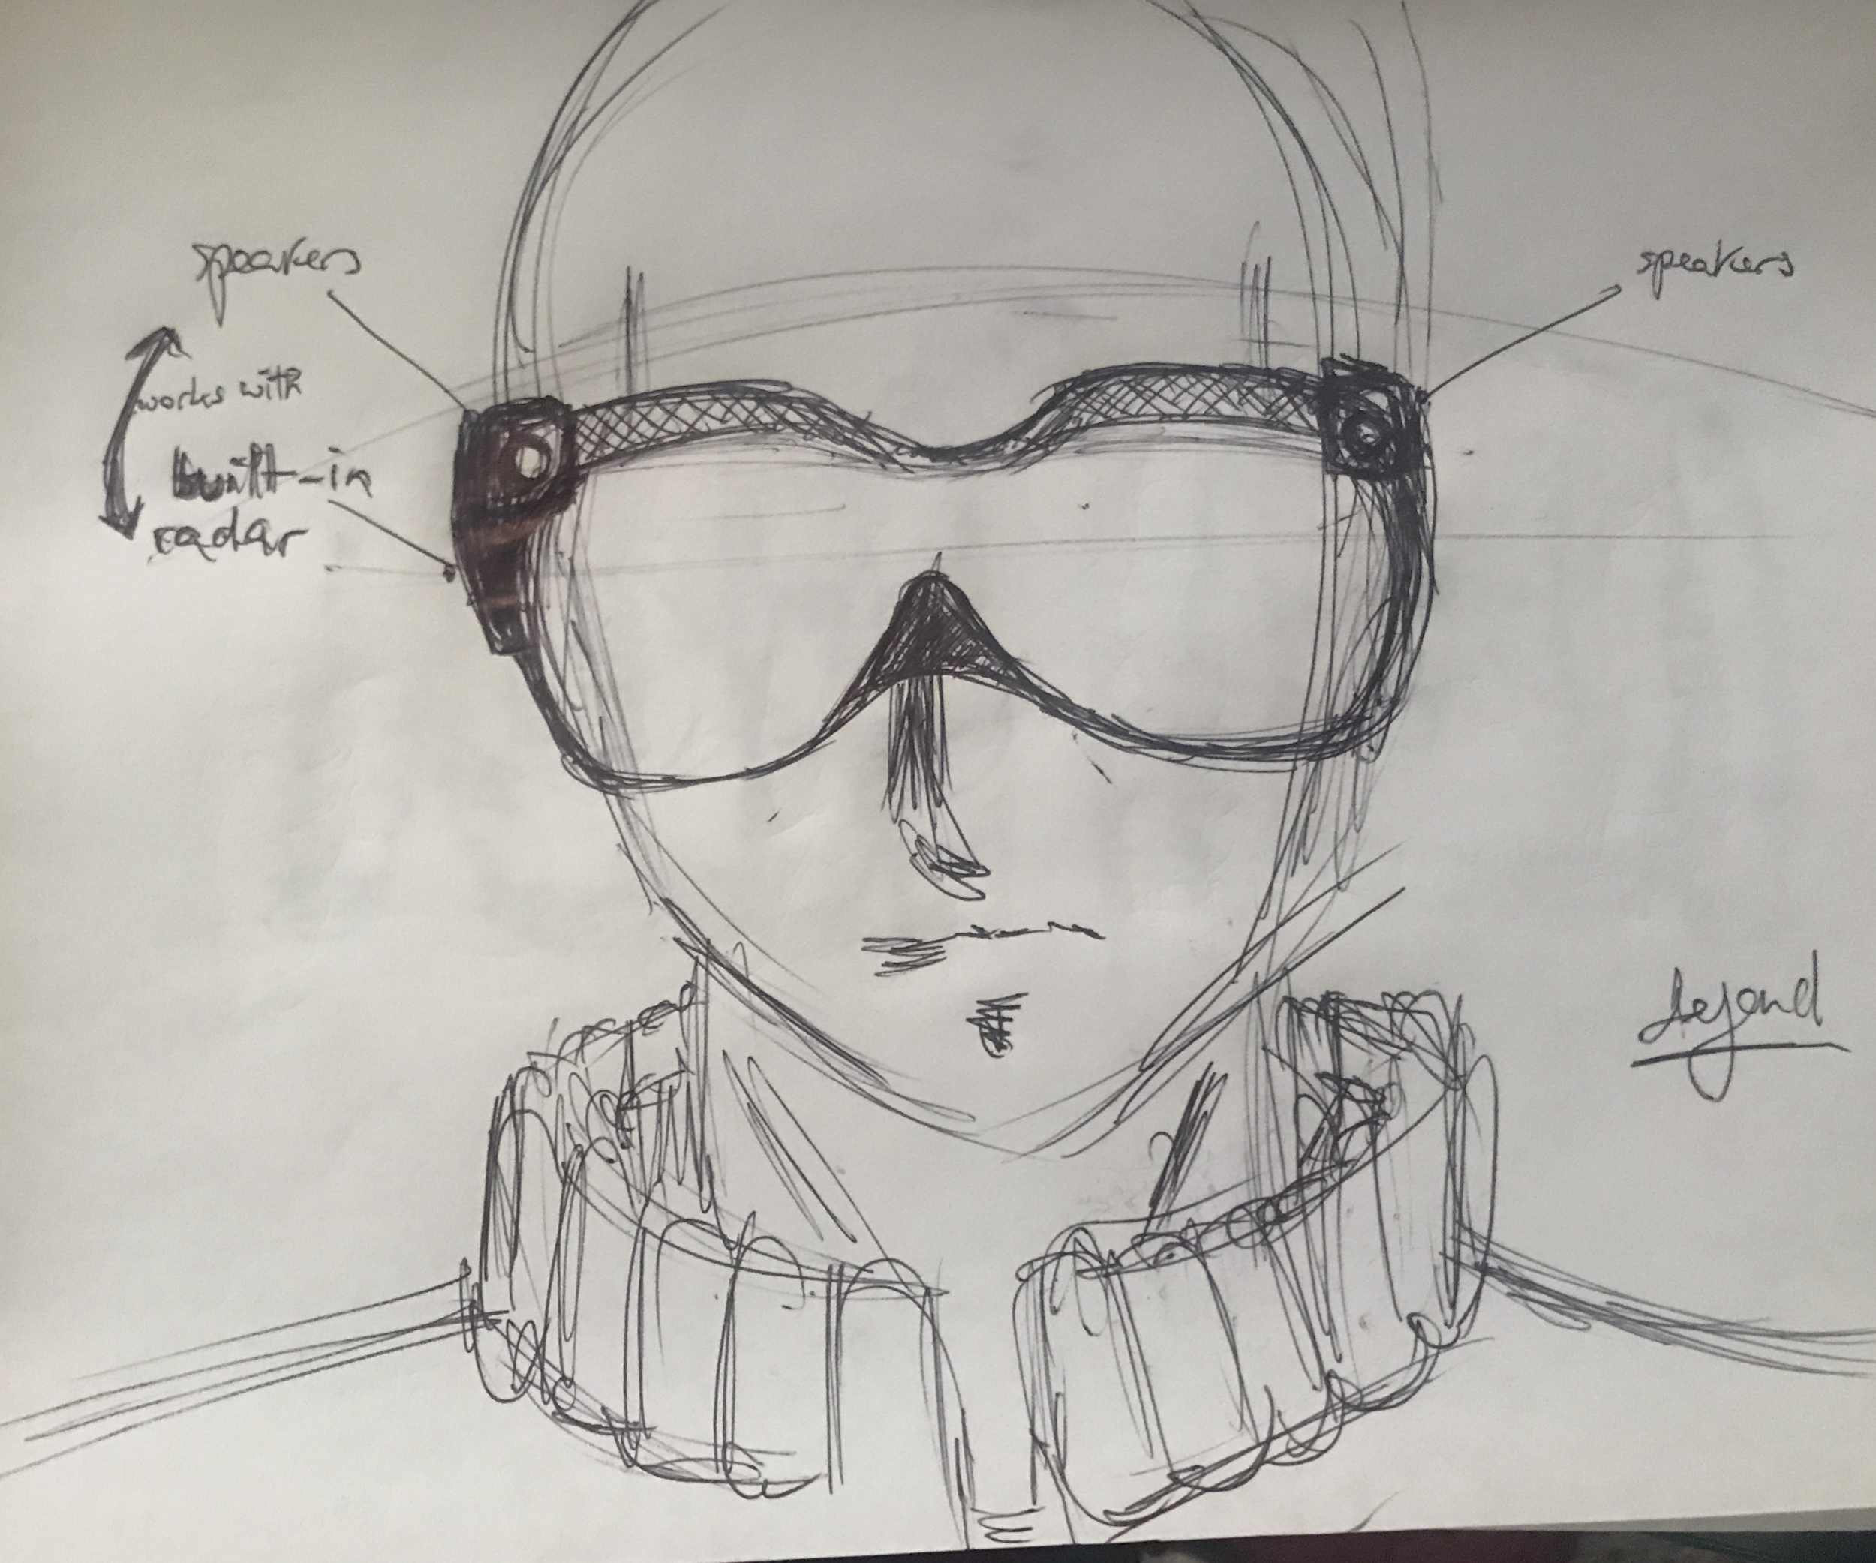

*Figure 6 displays initial concept of smart goggles incorporating Radar Technology*

Figure 7

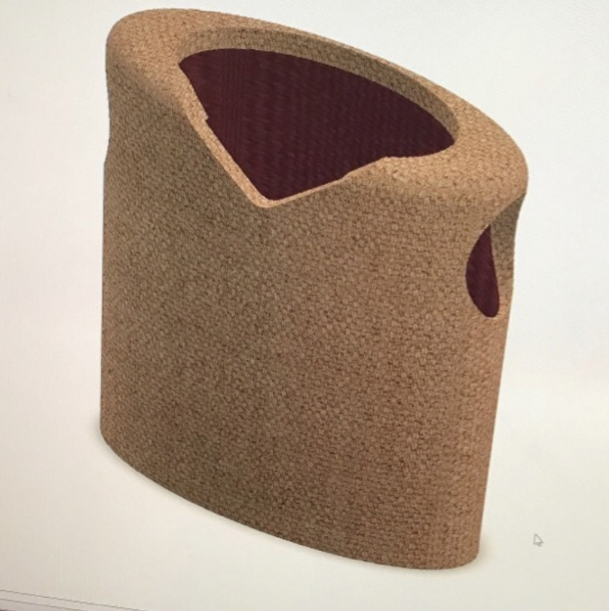

Figure 7 is the initial CAD model of the wearable device (the vest)

Figure 8

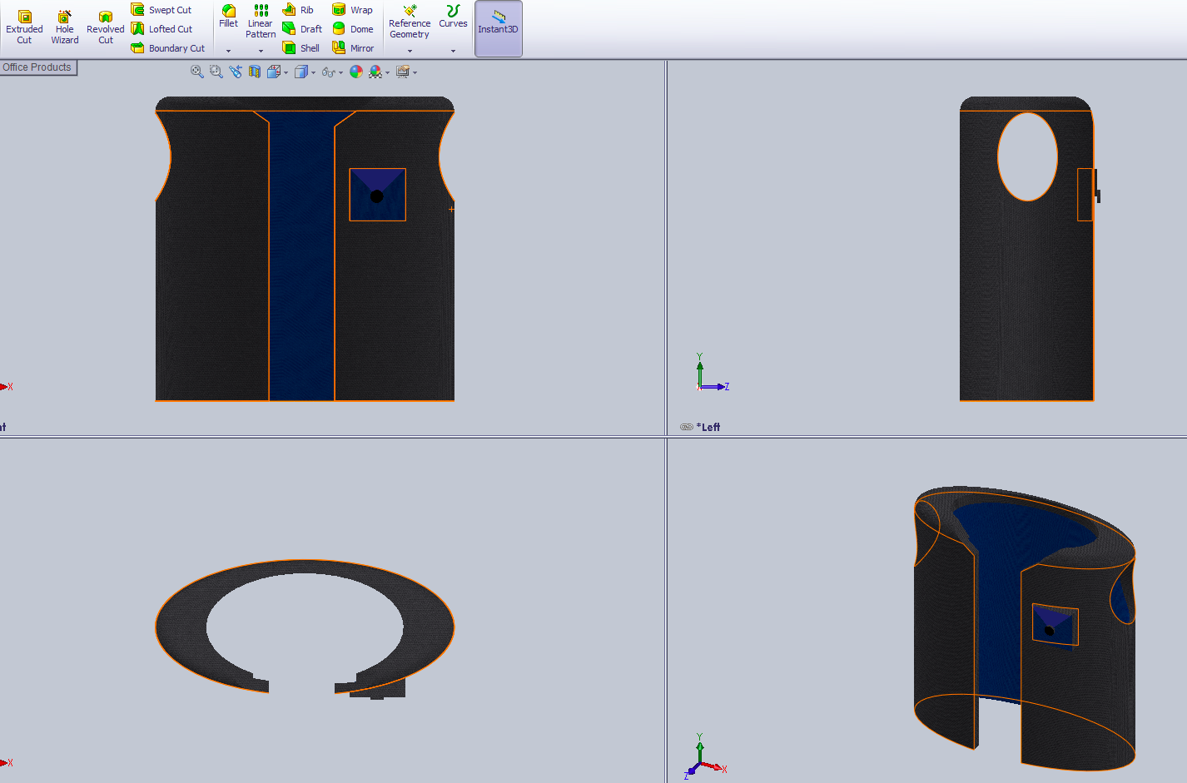

Figure 8 is the completed CAD model of the vest in four views

Figure 9

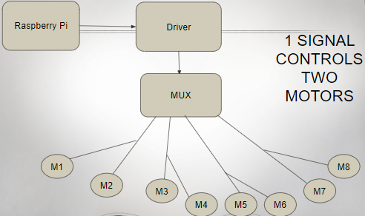

**Implementation of Task 2**

*Figure 10*



*Figure above shows the circuit with all the components connected*

*Figure 11*



*Pictured above is a snapshot of the vibrating motor on multisims*

*Figure 12*

*Pictured above is a snapshot of the PWM on multisims*

Radar evaluation

A RADAR(**RA**dio **D**etection **A**nd **R**anging or **RA**dio **D**irection **A**nd **R**anging) is a detection system that make use of radio waves(Electromagnetic waves) to measure the angle, velocity and range of an object.

A radar system works by sending out radio waves through a transmitter and receiving these bounced back radio waves by means of a receiver. Using this technology, it is possible to calculate the distance between the radar and the obstacle. By observing the time difference between the release of the radio waves, and the reception of the bounced back radio waves, the distance can be calculated

**D=CT/2**

Where C is the speed of light(299792458 m/s)

D is the distance travel by the radio waves

And T is the time travelled by the radio waves.

Since the radio waves travel twice the distance, one going and one returning, the distance is divided in the formal to determine the actual distance between the radar and the object.

The radar transmits a high pulse power but short radio pulse. This pulse direction is focused mainly by the antenna, and the pulse will be propagated by this antenna and will travel in this direction with speed of light.

If these radio waves are directed towards an obstacle like say an airplane, they will get reflected, although as a weaker returning signal. The pulse will be reflected as parts of the energy of the pulse will be spread out in all directions. A relatively very small part is received by the radar, which is then collected by the radar antenna.

Since radio waves are propagated at the speed of light, their distance traveled is calculated by runtime of high frequency transmitted signals. The real range(or the line-of-sight range) of the object from the radar is known as **Slant Range** and the **Ground Range** is the horizontal distance between the transmitter and the object. Using these, the elevation of an object can be calculated.[1]

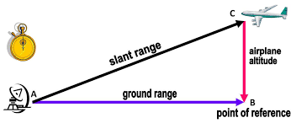

Figure1: Slant Range and Ground Range[2]

When the radar receives the returned signal, the distance can be measured using a oscilloscope. On the oscilloscope, is a luminous point that moves synchronously with the transmitted pulse and this luminous point leaves a trail. On the oscilloscope, there will be an initial “spike” for the transmission of the propagated pulse and a second “spike” for the reception of the returning pulse. The distance between the two pulses on the oscilloscope is a measurement of the distance(slant range) between the radar and the object.

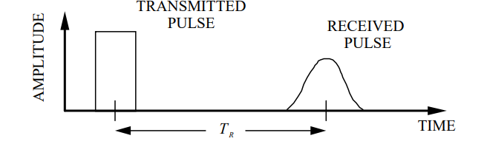

Figure2: shows time between transmitted pulse and received pulse. Received pulse has a reduced amplitude as a result of absorption.[2]

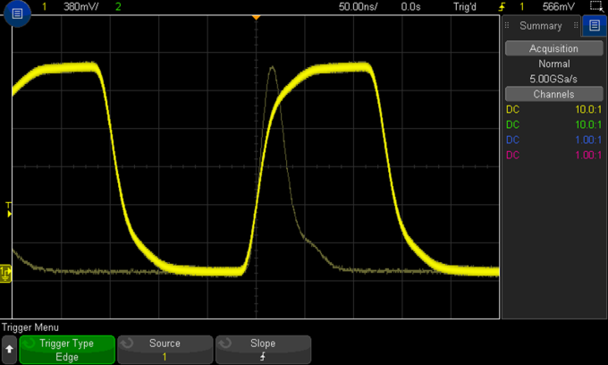

Figure3: Oscilloscope view. The distance between these two pulses can be used to calculate the distance between the radar and the object.[3]

The type of radar that will be used in this project is the **Pulse Doppler Radar**. Pulse Doppler Radar transmits high pulse repetition frequency in order to stay clear of doppler ambiguities. The transmitted signal and the received echo signal are combined in a detector to get the Doppler shift and the difference signal is filtered out by using a Doppler filter in which the unwanted noise signals are rejected and removed.

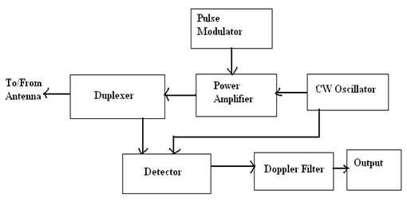

Figure4: Pulse Doppler Radar System Layout[4]

Radar Features Required in this Project

These features are the features that were observed in the determining the radar we want for our project. The most important features to us were those that improved the obstacle detection, fast response, range and power of the radar. Based on these feature, the IWR6843 was chosen as the best possible radar choice.

Resolution: This is the . In the below table, resolution of the radars are compared to the resolution of a 24 GHz sensor. For comparison, the resolution of a 24 GHz sensor will be written as **X**.

Frequency:

Radars that Were Evaluated

|  |  |  |  |  |
| --- | --- | --- | --- | --- |
|  | IWR6843 | A111 | OPS242 | IWR1443 |
| RESOLUTION | 16X | 7X |  | 43X |
| FREQUENCY  (GHz) | 60-64 | 60 |  | 76-81 |
| AVAILABILITY | YES | NO | YES | NO |
| COST($)/UNIT | 42 | 49.95 | 189 | 798 |
| No. of RX | 4 | 1 |  | 4 |
| No. of TX | 3 | 1 |  | 3 |
| ADC SAMPLING RATE | 25 | - |  | 37.5 |
| TX POWER(dBM) | 10 | 10 |  | 12 |
| ARM CPU | ARM R4F @ 200MHz | - |  | ARM R4F @ 200MHz |
| RAM(KB) | 1792 | - |  | 576 |
| INTERFACE | I2C LVDS QSPI SPI UART | - |  | CAN  CSI-2  I2C  LVDS  QSPI  SPI  UART |
| OPERATING TEMPERATURE  RANGE(oC) | -40 to 105 | -40 to 85 | -40 to 85 | -40 to 105 |
| FIELD OF VIEW  (AZIMUTH)(O) | 108 | 80 |  | 120 |
| CLOCK(MHz) | 40 | 50 |  | 40 |
| FIELD OF  VIEW  (ELEVATION)  (O) | 44 | 40 |  | 40 |
| MAX DISTANCE DETECTION(m) | 4.8 | 2 | 25 | 12.79 |
| PRODUCT CONTINUITY | YES | YES | YES | NO |

For table See [5],[6],[7],[8]

A111 radar-$50

Omnipresence Radar(OPS242-A Short Range Radar Sensor)

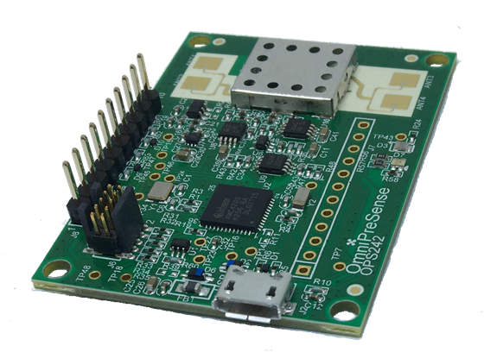

Awr1443

IWR6843(including the Iwr6843isk and the mmwaveicboost )

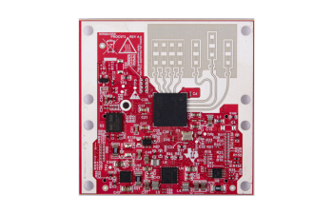

IWR1443(TI IWR1443-DATA-CAPTURE-BNDL radar module)-$798

1. **Conclusion.**

By the end of the project, conclude the project and your learning experience.

1. **Acknowledgement**

If you get help or support from someone else (besides the team member and the advisor) and want to show your appreciation, put here (**do not include the advisor**).

1. **Appendix**

You can put reference info here, including: i) specs of components used in the system, ii) source code (must be here but not in the body text), iii) CAD figures, etc.

1. **Component Specs**
2. ***Specs of Arduino Due***

...

1. ***Specs of Raspberry Pi***

…

1. **Source Code.**
2. ***Source Code of Graphic User Interface***

…

1. ***Source Code of Robotic Arm***

…

1. **REFERENCES**

[1] D. Vantrease, R. Schreiber, M. Monchiero, M. McLaren, N. P. Jouppi, M. Fiorentino*, et al.*, "Corona: System Implications of Emerging Nanophotonic Technology," in *Computer Architecture, 2008. ISCA '08. 35th International Symposium on*, 2008, pp. 153-164.

[2] X. Zhang and A. Louri, "A multilayer nanophotonic interconnection network for on-chip many-core communications," in *Design Automation Conference (DAC), 2010 47th ACM/IEEE*, 2010, pp. 156-161.

[3] C. Batten, A. Joshi, J. Orcutt, A. Khilo, B. Moss, C. Holzwarth*, et al.*, "Building manycore processor-to-DRAM networks with monolithic silicon photonics," in *High Performance Interconnects, 2008. HOTI '08. 16th IEEE Symposium on*, 2008, pp. 21-30.

[4] Y. Pan, P. Kumar, J. Kim, G. Memik, Y. Zhang, and A. Choudhary, "Firefly: illuminating future network-on-chip with nanophotonics," in *IEEE/ACM Intl. Symp. on Computer Architecture (ISCA)*, 2009, pp. 429-440.

[5] N. Kirman, M. Kirman, R. K. Dokania, J. F. Martinez, A. B. Apsel, M. A. Watkins*, et al.*, "Leveraging Optical Technology in Future Bus-based Chip Multiprocessors," in *Microarchitecture, 2006. MICRO-39. 39th Annual IEEE/ACM International Symposium on*, 2006, pp. 492-503.

[6] J. M. Cianchetti, C. J. Kerekes, and H. D. Albonesi, "Phastlane: a rapid transit optical routing network," in *Proceeding of: 36th International Symposium on Computer Architecture (ISCA)*, 2009, pp. 441-450.

[7] A. Shacham, K. Bergman, and L. P. Carloni, "Photonic Networks-on-Chip for Future Generations of Chip Multiprocessors," *Computers, IEEE Transactions on,* vol. 57, pp. 1246-1260, 2008.

[8] A. Shacham, K. Bergman, and L. P. Carloni, "On the Design of a Photonic Network-on-Chip," in *First International Symposium on Networks-on-Chip, 2007. NOCS 2007*, 2007, pp. 53-64.

[9] M. Kwai Hung, Y. Yaoyao, W. Xiaowen, Z. Wei, L. Weichen, and X. Jiang, "A Hierarchical Hybrid Optical-Electronic Network-on-Chip," in *VLSI (ISVLSI), 2010 IEEE Computer Society Annual Symposium on*, 2010, pp. 327-332.

[10] D. Ding and D. Z. Pan, "OIL: a nano-photonics optical interconnect library for a new photonic networks-on-chip architecture," presented at the Proceedings of the 11th international workshop on System level interconnect prediction, San Francisco, CA, USA, 2009.

[11] A. Joshi, C. Batten, K. Yong-Jin, S. Beamer, I. Shamim, K. Asanovic*, et al.*, "Silicon-photonic clos networks for global on-chip communication," in *Networks-on-Chip, 2009. NoCS 2009. 3rd ACM/IEEE International Symposium on*, 2009, pp. 124-133.

[12] D. Vantrease, R. Schreiber, M. Monchiero, M. McLaren, N. P. Jouppi, M. Fiorentino*, et al.*, "Corona: system implications of emerging nanophotonic technology," in *Proc. 35th IEEE/ACM Int'l Symp. Computer Architecture (ISCA)*, 2008, pp. 153-164.

[13] L. Zhang, E. Regentova, and X. Tan, "A 2D-Torus Based Packet Switching Optical Network-on-Chip Architecture," presented at the *IEEE International Symposium on Photonics and Optoelectronics* (SOPO 2011), Wuhan, China, 2011.

[14] L. Zhang, E. E. Regentova, and X. Tan, "Packet switching optical network-on-chip architectures," *Comput. Electr. Eng.,* vol. 39, pp. 697-714, 2013.

[15] G. Huaxi, X. Jiang, and W. Zheng, "A novel optical mesh network-on-chip for gigascale systems-on-chip," in *Circuits and Systems, 2008. APCCAS 2008. IEEE Asia Pacific Conference on*, 2008, pp. 1728-1731.

[16] G. Huaxi, X. Jiang, and Z. Wei, "A low-power fat tree-based optical Network-On-Chip for multiprocessor system-on-chip," in *Design, Automation & Test in Europe Conference & Exhibition, 2009. DATE '09.*, 2009, pp. 3-8.

[17] Y. Yaoyao, X. Jiang, H. Baihan, W. Xiaowen, Z. Wei, W. Xuan*, et al.*, "3-D Mesh-Based Optical Network-on-Chip for Multiprocessor System-on-Chip," *Computer-Aided Design of Integrated Circuits and Systems, IEEE Transactions on,* vol. 32, pp. 584-596, 2013.

[18] A. Shacham, K. Bergman, and L. P. Carloni, "Photonic networks-on-chip for future generations of chip multiprocessors," *IEEE Trans. Computers,* vol. 57, pp. 1246-1260, 2008.

[19] A. W. Poon, F. X. Xu, and X. Luo, "Cascaded active silicon microresonator array cross-connect circuits for WDM networks-on-chip," in *Proc. SPIE*, 2008, p. 689812.

[20] M. Lipson, "Compact Electro-Optic Modulators on a Silicon Chip," *IEEE Journal of Selected Topics in Quantum Electronics,* vol. 12, pp. 1520-1526, 2006.

[21] M. Lipson, "Guiding, modulating, and emitting light on Silicon-challenges and opportunities," *Lightwave Technology, Journal of,* vol. 23, pp. 4222-4238, 2005.

[22] T. Xianfang, Y. Mei, Z. Lei, J. Yingtao, and Y. Jianyi, "Wavelength-routed optical networks-on-chip built with comb switches," in *Photonics Conference (IPC), 2013 IEEE*, 2013, pp. 46-47.